A Novel Goniophotometer with Pursuit Mirror
Li Junkai¹, Wang Jianping¹, Mou Tongsheng²
¹Zhejiang University Sensing Instruments Co., Ltd, Hangzhou, China
²Optical Engineering Department of Zhejiang University, Hangzhou, China

abstract
A novel goniophotometer with pursuit mirror is presented to meet the higher requirements of goniophotometric measurement by LED luminaires, especially for application in road lighting and flood lighting, because of temperature sensitivity and complicated beam distribution. Through adoption of a rotation pursuit mirrors, the operating position of measured luminaires, the optical axis of measured beam, the position and direction of incident beam on the mirrors, and the detector position can be kept in invariableness. Furthermore, the photometric distance can be lengthened, and stray light can be eliminated effectively by setup of diaphragms in the measuring channel between the detector and measured luminaire.
Keywords: luminous intensity distribution, a goniophotometer, LED luminaires

Goniophotometry measurement
It is more challenging to measure the spatial luminous intensity distribution of LED luminaires, due to complicated beam output through reflectors and refraction optics. Firstly, in order to achieve far-field luminous intensity measurement, the detecting distance in the goniophotometer should be long enough to meet far-field photometric principle, and mostly be larger than ten times of the maximum dimension of the light emitting area of the measured luminaires with wide beam as FL luminaries, while for narrow beam spread luminaires, e.g. floodlight, the distance should be at least 200/θ (θ is half peak side angle of the measured beam) times of the maximum dimension of the light area^{[1][5]}.
Especially for LED luminaries with multi-sub-lamps, because of narrow beam of LED lamps, the light beam will not be uniformity on the detector in the short detection distance as in the figure1. The inverse square photometric law in finite measuring distance can’t be applied to exact measurement of luminous intensity distribution for these luminaires .
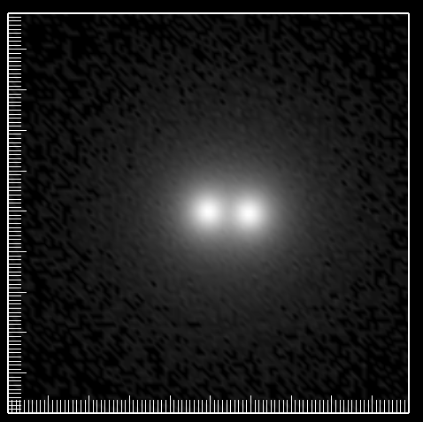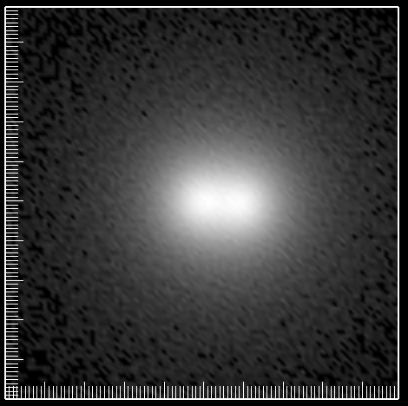
a) Short distance b) Long distance
Figure1 Comparison between different detecting distances
An example of a LED luminaire, consisting of several sub-LED lamps as in the figure2,
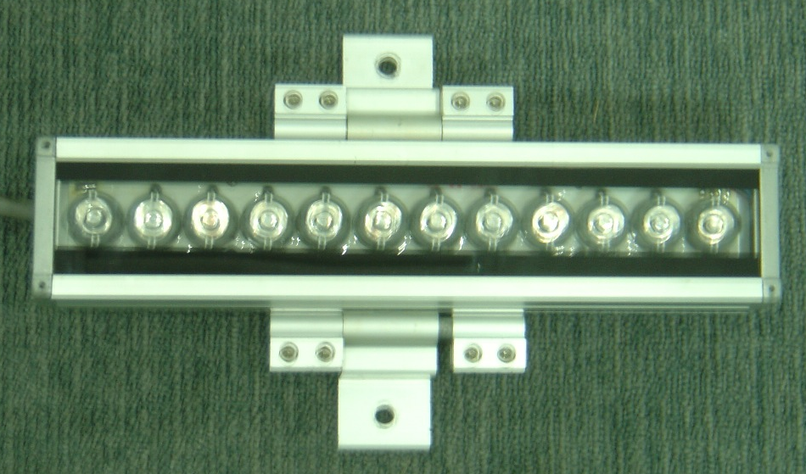
d
Figure 2 a LED luminaire
The detecting distance L is dependent on the luminaire dimension (d=600mm), the beam spread distribution and the arrangement of sub-LED lamps. The relationship between luminous intensity and detection distance L is shown in the figure4 for a LED luminaire with 16 degree of beam angle as in the figure3. More than 20m of detecting distance should be considerable to keep the error less than 1.5% related to far-field measurement of luminous intensity.

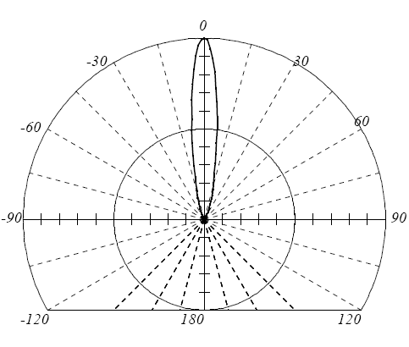
Figure3 Beam distribution of LEDs
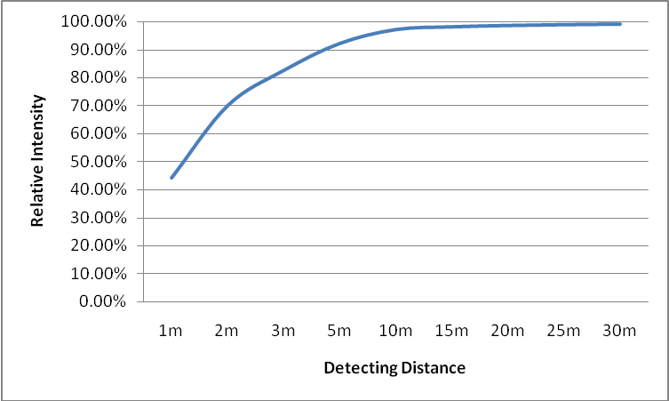
Figure4 Luminous Intensity vs detecting distance.
Moreover, Stray light is one of the most important factors in goniophotometry measurement. It could be carking and inconstant in the measurement of steep beam distribution, and difficult to be removed from measuring signal. It’s more important that the photodetector should receive the light only from test luminaire or luminaire image by a mirror. Other visible area of the photodetector should be not illuminated directly by light sources. Even the black paint will produce more than 4 percent of reflection, which is spectrally not neutral sometimes.
It should be noticeable that the stray light is also related to the dimension of reflection mirror used in the goniophotometer. The maximum size of the measurable luminaires would be therefore limited by the room space of laboratory. For example, for 4.2m height of the lab room, the maximum size of measured luminaires in a goniophotometer with a mirror would be limited in 1.0m diameter. Otherwise, the stray light by mirror imaging will be mixed to the measured light in the measurement direction, and bring obvious error as shown in the figure5,
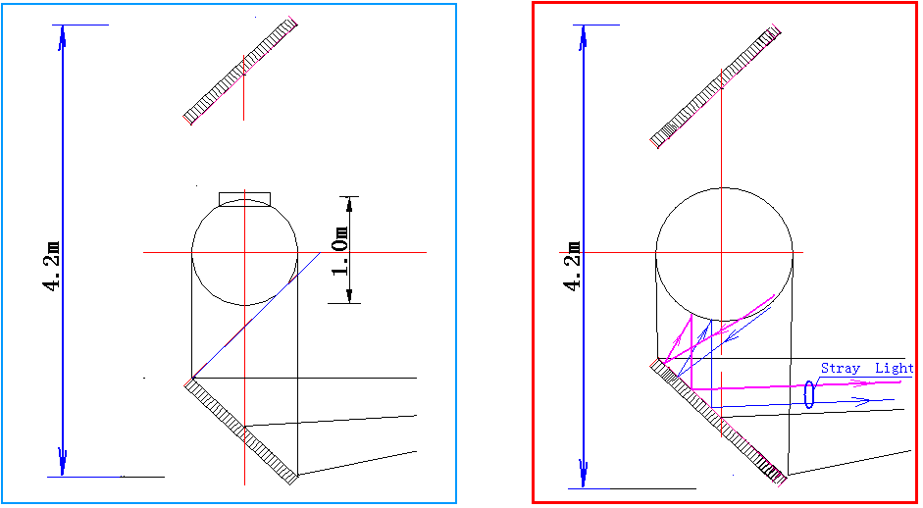
Figure5. The stray light caused by mirror imaging
Besides, in view of junction temperature dependence of LED lamps, it’s more important to keep the temperature of heat sink of LEDs in invariableness. The surrounding airflow around measured luminaries should be minimized.

typical constructions of goniophotometer
Nowadays, several typical constructions of goniophotometer with reflection mirror are often used in the world ^{[2]}.
In a goniophotometer with centre rotating mirror (Figure6), the fixed detecting beam path is convenient to set the diaphragms between the measured luminaire, the reflection mirror and the photodetector in order to eliminate the stray light effectively, and to get the light incident on the detector perpendicularly. However, the movement of the luminaire would leads to ambient air motion and a possible shift of the values, which doesn’t show great promise for temperature sensitive luminaires, such as fluorescent lamps and LED lamps ^{[3]}. Accordingly, the movement speed of measured luminaires has to be limited to keep the light fluctuation caused by the temperature to be minimum.
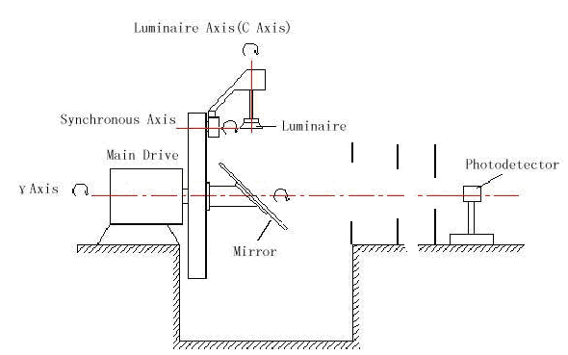
Figure6 A goniophotometer with centre rotating mirror
In a goniophotometer with circular moving mirror (Figure7), the luminaire position is fixed, while the beam axis moves around cone, accordingly only diaphragms with annular aperture can be applied, but it should be considerable that the sensitivity difference of the detector at different direction and the wider acceptance angle of detecting beam can cause the error of stray light.
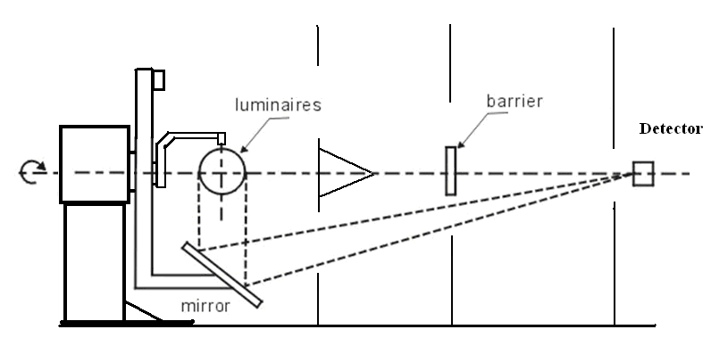
Figure7. A goniophotometer with moving mirror
Another goniophotometer with a second fixed mirror is shown in the figure8 ^{[4]}. In this structure, the light from the luminaire is reflected by the first rotating mirror, and incidents to the fixed mirror, and finally captured by the detector installed on the rotating arm of the goniometer. However, there is a fatal bug that it is difficult to set useful diaphragms for eliminating stray light between the measured luminaire, the fixed mirror and the detector.
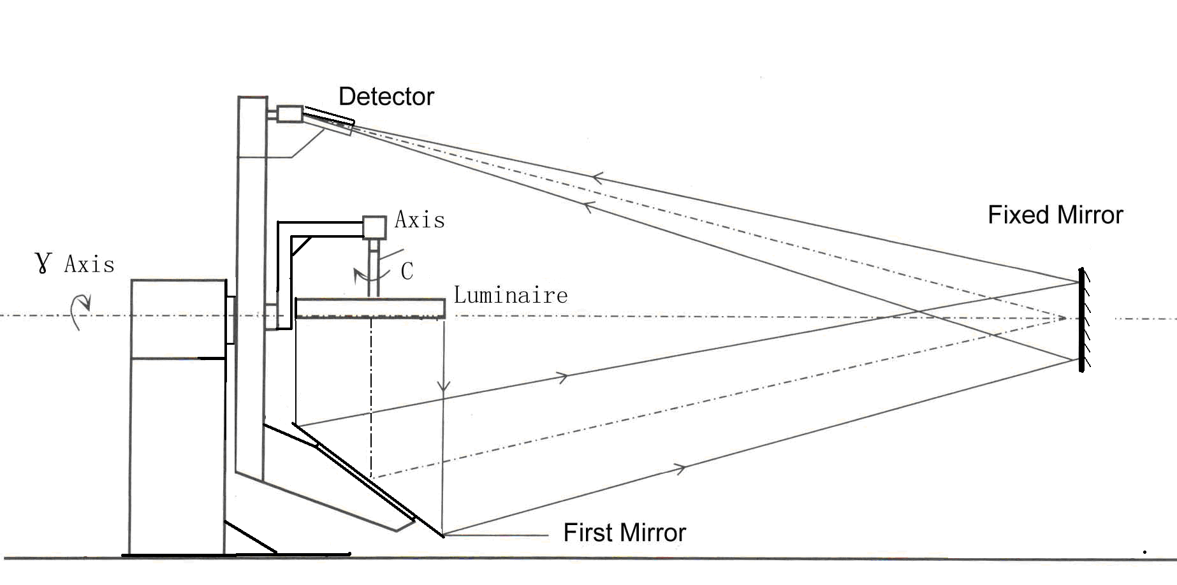
Figure8 A goniophotometer with a second fixed mirror
A long detector tube can be used to decrease the effect of stray light, however it should be noticed for vibration of the long tube during the measurement, and always the stray light reflected from the floor, the walls, and the mirror edge will incident on the detector since the detector has to be larger acceptance area as shown in the figure9. Moreover, as the directional reflectance difference on the fixed mirror will also be brought in this construction.
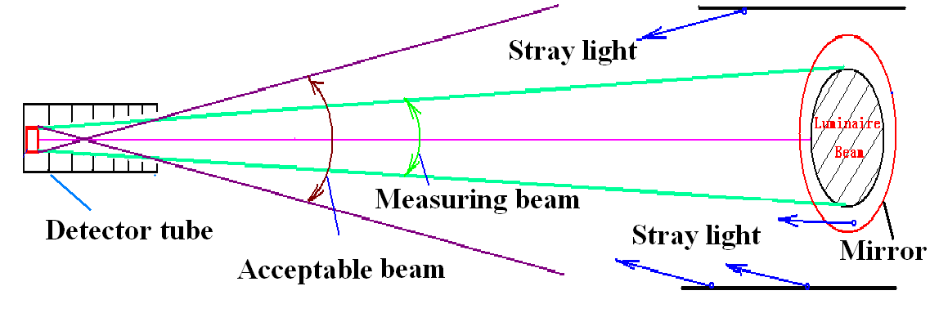
Figure9. Stray light acceptance

A Goniophotometer with Pursuit Mirror
A construction of a new goniophotometer with pursuit mirror is developed as in the figure10. A moving mirror rotates around the horizontal axis, through the photometric centre of the fixed measured luminaire, and reflects the measured beam to the pursuit mirror, which is placed in the opposite position and rotates with the above moving mirror synchronously. The measured beam is then reflected by the pursuit mirror perpendicularly towards to the fixed detector around the horizontal rotation axis.
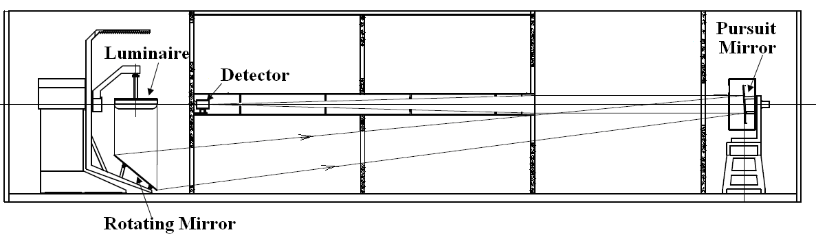
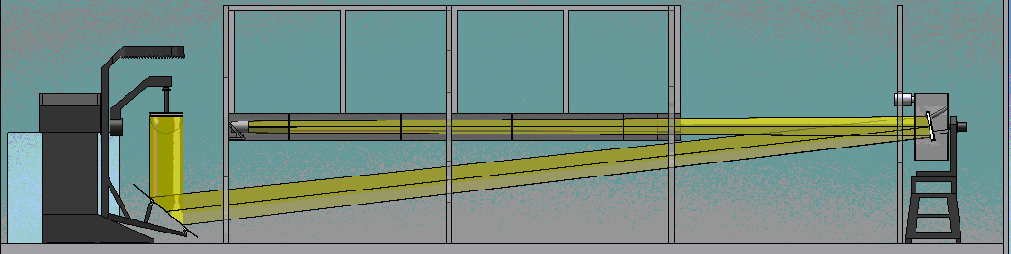
Figure10 A goniophotometer with pursuit mirror
A experiment configuration of the goniophotometer shown in the figure11.
1) Equipment height: 4.3m
2) Rotating Mirror: 1.5m×1.0m ellipse
3) Photometric Distance: 30m (Distance from measured luminaire to pursuit mirror: 17m; Distance from pursuit mirror to the detector: 13m).

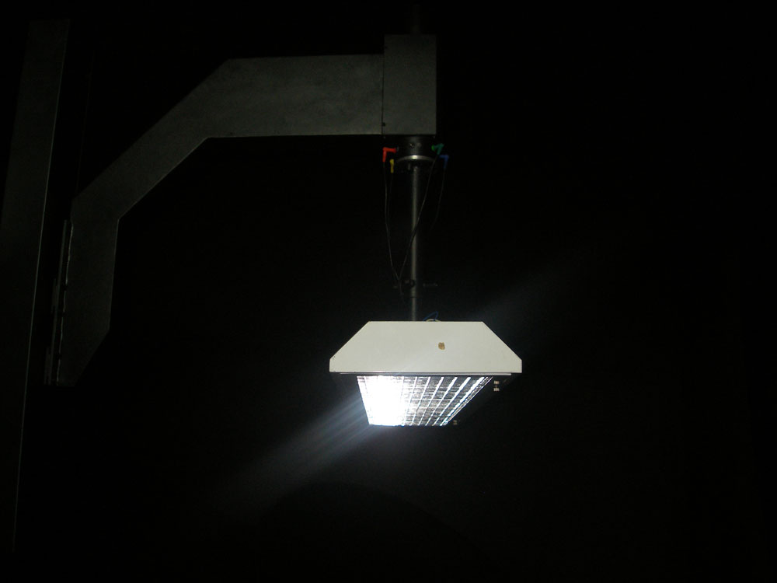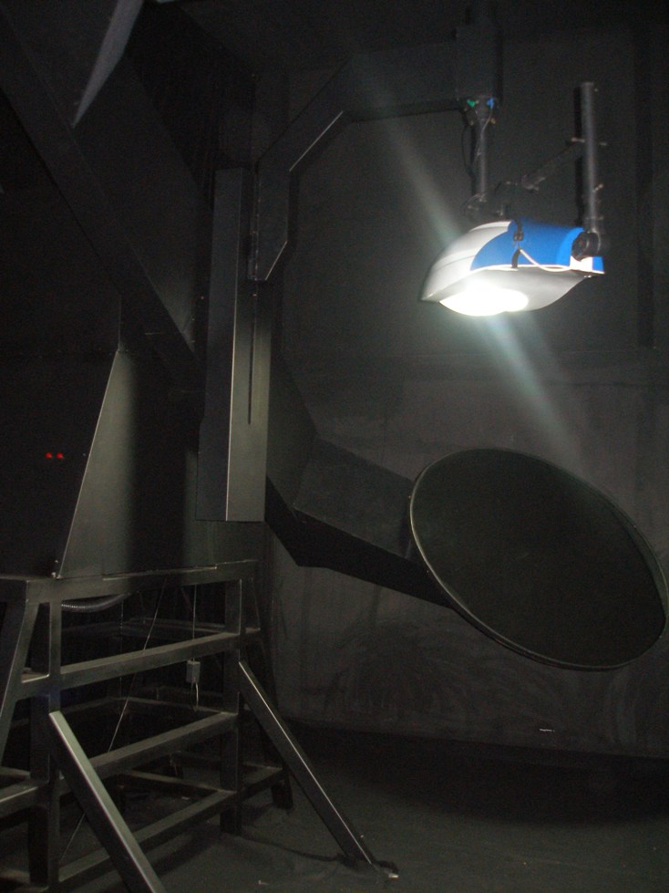
Figure11 A laboratory of the gonio-photometer with pursuit mirror
Since the beam path from the pursuit mirror to the fixed detector is constant, it’s benefit to eliminate stray light by setting diaphragms between both of them as in the figure12. Furthermore, we can also set diaphragms with annular aperture between the rotating mirror and the pursuit mirror.
The temperature effects caused by the airflow can be minimized for measured luminaires in a fixed position.
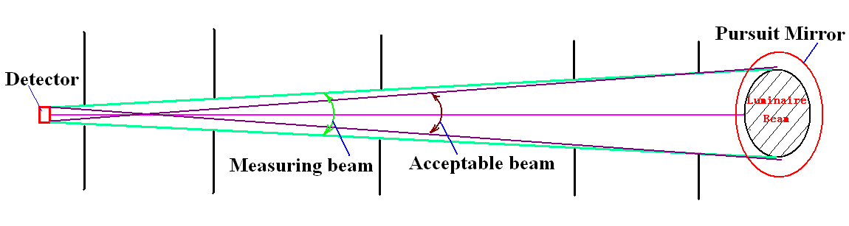 Figure12. Stray light elimination
The detector on a fixed position of the centre axis could trace the measuring beam by a synchronous rotation pursuit mirror, and the light beam perpendicularly incidents on the detector for a realization of the constant sensitivity.
What’s more, Comparing with above goniophotometer with a second fixed mirror, the incidence angle on the pursuit mirror is reduced a half, as a result that the error caused by polarization of the light will be less. Another advantage for this construction is that the reflection is constant because of the invariable incidence direction on the pursuit mirror. In addition, a synchronous pursuit laser device can be used to ensure the synchronization between the rotating mirror and the pursuit mirror.
A fixed position of the detector is important to implement good S/N value of photoelectric signal. And also, the detector could be easily changed into a spectroradiometer or a colorimeter for measurement of the spatial chromaticity difference of LED luminaires.

Conclusion
The novel goniophotometer with pursuit mirror has its characteristics compared with previous typical structures, especially on the eliminating stray light, reducing temperature and orientation effects, realizing high S/N of photoelectric signal and so on. Therefore, it is suitable for the measurement of spatial luminous intensity distribution of the luminaries, which are temperature sensitive and complicated in the beam distribution, such as LED luminaries in application of road lighting and flood lighting, etc.

references
1. IESNA，IES Lighting Handbook, NewYork, 2000
2. CIE Technical Report, The Measurement of Absolute Luminous Intensity Distributions, CIE Pub. NO. 70
3. CIE Technical Report, The Photometry and Goniophotometry of Luminaires, CIE Pub. NO. 121
4. An Automated Goniophotometer For Luminaire Characterization, V. F. Muñoz, J. Gómez-de-Gabriel, 15th Triennial World Congress, Barcelona, Spain,2002
5. CIE Technical Report, LED Measurement, CIE Pub. NO. 127

Acknowledgements
Authors wish to thank to Dr. George Sauter of PTB for the suggestion on stray light elimination of the goniophotometers with a mirror in CIE 2007 Beijing Session.
Authors: Li Junkai, Wang Jianping,Mou Tongsheng
Affiliation:Hangzhou Zhejiang University SENSING Instruments Co.,Ltd
Address: Building G, Xixi Road No.525, Hangzhou, China
Phone+86-571-85021543
Fax+86-571-87977635
E-mail: sensing@sensing.net.cn

